Alexander Shah
Project 3 – IR Tach
2024-02-25
EN.605.715.81.SP24

Table of Contents
Requirements 1
Design 2
Implementation 3
Demo 4
References 5

Requirements
This project uses an Arduino UNO, an IR emitter and photodiode, resistors, and wiring to read blocked IR signals during a period of 1 second. This is done in order to capture the amount of rotations past the sensor, which is used to calculate the rotations past the sensor per minute, or rpm, giving us an effective tachometer. This project uses interrupts to count rotations during a period defined by the internal clock timers of the arduino, which then returns to the round robbin loop in order to calculate and display the rpm value. This project was written and tested using the Arduino IDE in C like language to implement the Project 3 requirements as provided.

Design
The Arduino UNO is connected to a PC for power and serial output. The design is split across two breadboards to leave a gap in the middle for the spinning object. This necessitates using wiring to jump the power across the breadboards which is why you see a few extra jumpers. The emitter is always driven, and the photodiode is connected to digital pin 2 for interrupt capabilities. The IR emitter and photodiode are wired up using resistors (10k ohm for the photodiode and 220 for the emitter) to 5v power and ground and oriented pointing toward each other so that the object passing between the emitter and receiver occludes the sensor for a brief moment, causing a falling state in the photodiode, these falling events from the sensor are used in an interrupt to count up the rotations per second, and an interrupt every second reports back the approximated rotations per minute to the serial output during the round robin loop, where interrupts are disabled so that the calculations can be done uninterrupted. A flag is used to enter the main loop when the arduino timer has elapsed one second to report rotations per minute approximated from values obtained during that given second.
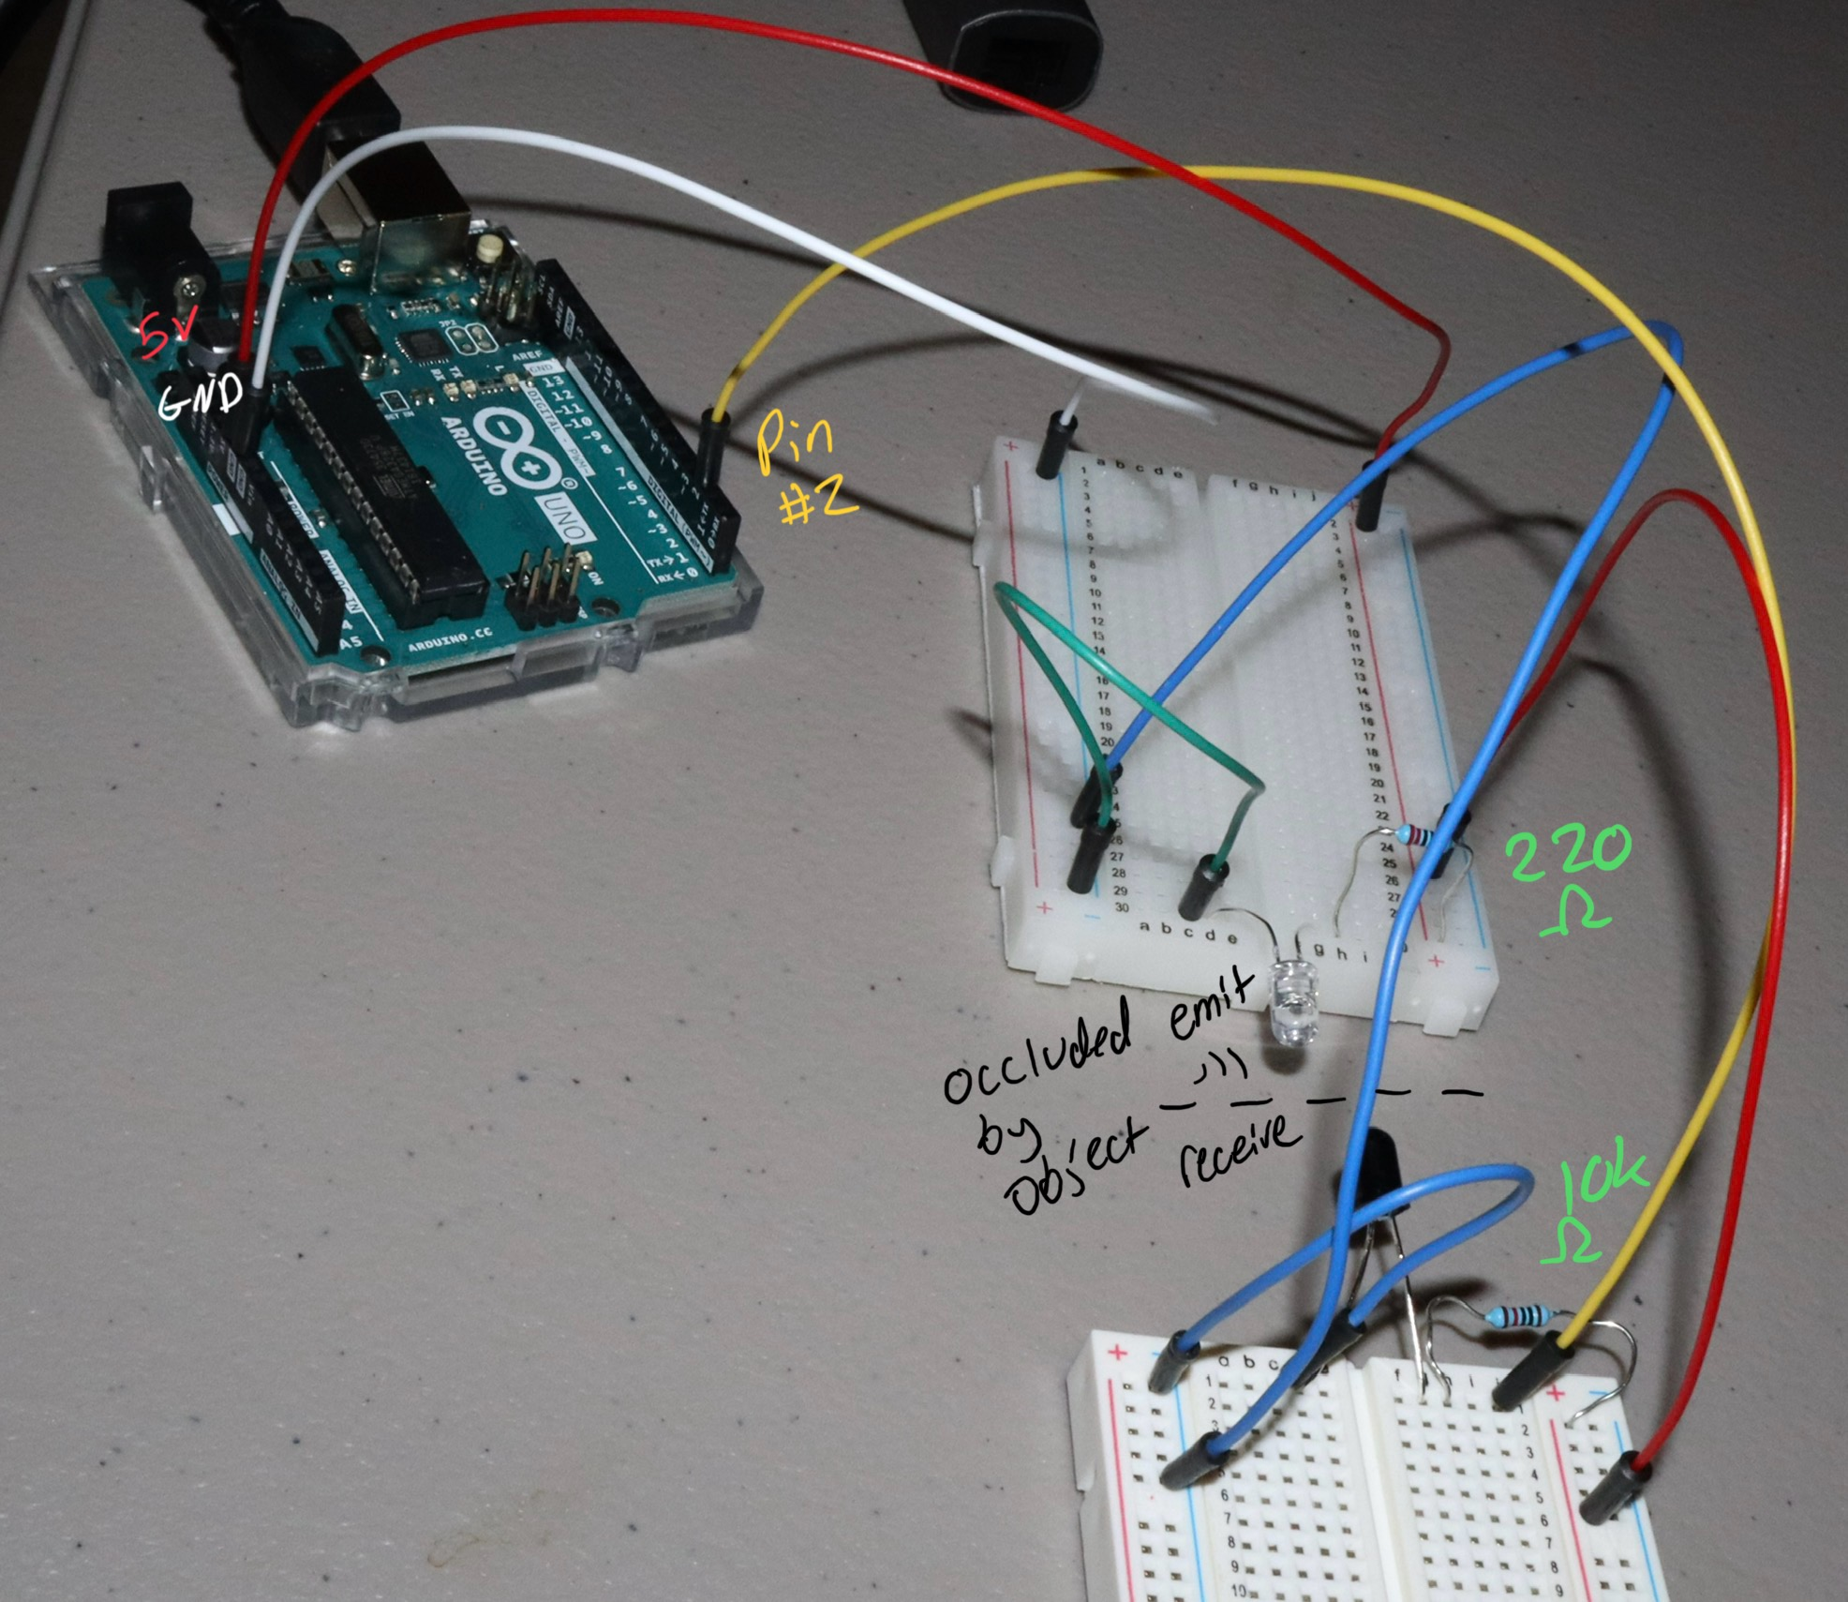

Implementation
``` proj3-irtach.ino
1 /*
2 Alexander Shah
3 Project 3 - IR Tach
4 2/25/24
5 */
6 //IR Photodiode
7 const int sensorPin = 2;
8 volatile unsigned int rpscount = 0;
9 // Flag for interrupt
10 volatile bool newDataAvailable = false;
11
12 void count_rps() {
13 rpscount++; // count rotations on pin 2 interrupt
14 }
15
16 void setup() {
17 Serial.begin(9600);
18 pinMode(sensorPin, INPUT);
19 //Reset timers and counter
20 TCCR1A = 0;
21 TCCR1B = 0;
22 TCNT1 = 0;
23 //Set compare match for every ~1 second
24 OCR1A = 15624;
25 // Turn on CTC mode
26 TCCR1B |= (1 << WGM12);
27 // Set CS12, CS10 bits for 1024 prescaler
28 TCCR1B |= (1 << CS12) | (1 << CS10);
29 // Enable timer compare interrupt
30 TIMSK1 |= (1 << OCIE1A);
31
32 //interrupt with sensor pin reading on falling
33 attachInterrupt(digitalPinToInterrupt(sensorPin), count_rps, FALLING);
34 }
35
36 void loop() {
37 if (newDataAvailable) {
38 //interrupts disabled during main loop
39 noInterrupts();
40 //reading rotations every ~1 second = rps * 60 = rpm
41 unsigned int rpm = rpscount * 60;
42
43 Serial.println(rpm);
44
45 //reset and resume interrupts
46 rpscount = 0;
47 newDataAvailable = false;
48 interrupts();
49 }
50 }
51
52 ISR(TIMER1_COMPA_vect) {
53 //set flag to enter main loop
54 newDataAvailable = true;
55 }

```

Demo
Below is a graph showing the captured RPM values written to the serial connection to the host. The large plateau shows the spinning drone motor with a piece of tape on it, this shows a consistent value near 2000 rpm, which is what we expect to see from a motor like this. I remove the motor from the sensor and wiggle my finger slowly, then quickly, then slowly again. I am capable of less consistent motion which is why we see the graph rise and fall more haphazardly in the second half compared to the stable spinning of the motor at much higher values.
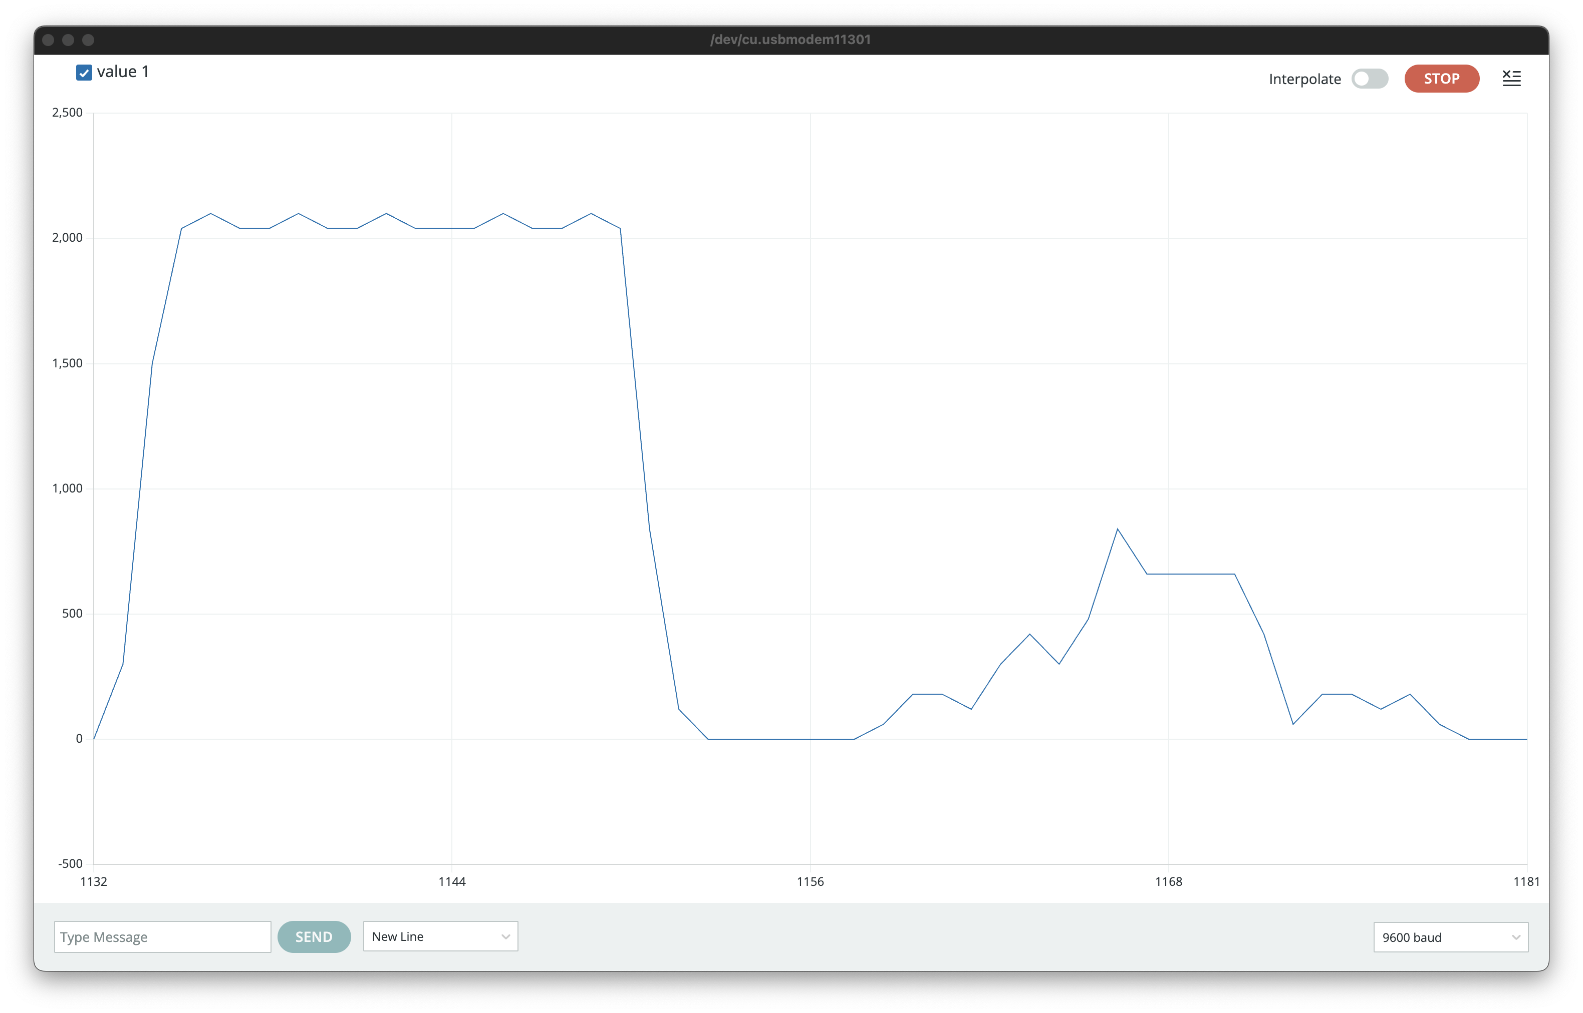
For a video demonstration, please view the view below:
https://drive.google.com/file/d/1vIkjuTXJhm-yKC7PZ8zlmOKmahacbZfi/view?usp=sharing

References
https://www.instructables.com/Arduino-Based-Optical-Tachometer/
https://startrobotics.blogspot.com/2013/05/how-to-use-ir-led-and-photodiode-with-arduino.html
https://labdegaragem.com/profiles/blogs/tutorial-tacometro-com-garagino-emissor-e-receptor-infravermelho

